Scaling and Serving Models

Lab 01: Automated Model Training

Service Introduction
Vertex AI pipeline templates are pre-built or customizable blueprints designed to automate machine learning (ML) workflows. They manage the orchestration between different stages of an ML pipeline, such as data processing, training, and deployment, allowing a focus on core ML tasks.
There are two main ways to get started with Vertex AI pipeline templates:
- Use a pre-built template: The Vertex AI Pipelines Template Gallery offers pre-built templates for common ML tasks, such as tabular classification. These templates can be selected, configured for specific needs, and executed with minimal effort.
- Create a custom template: Custom templates can be built from scratch using Kubeflow Pipelines (KFP), providing greater flexibility but requiring more development effort.

Problem
As a machine learning engineer at ML.inc, You frequently acquire and store data in BigQuery tables. To optimize the machine learning workflow and guarantee models are up to current with the most recent data, an automated pipeline must be developed. This pipeline should be scheduled to run at 9 a.m. every Tuesday. This pipeline's key tasks are data ingestion, preprocessing, model training, evaluation, and deployment. The solution should make use of Google Cloud's Vertex AI to provide scalability, dependability, and efficiency.

Solution
1. From the search bar at the top of the console, search for Vertex AI“.
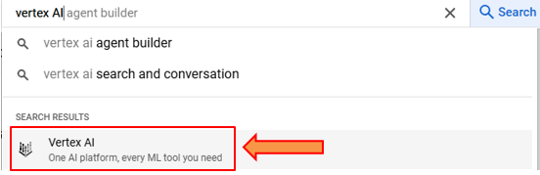
2. In the tools section, click on “pipelines”.
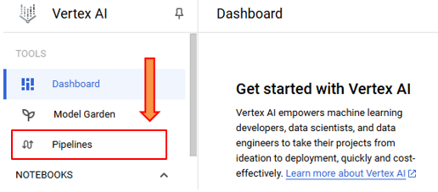
3. Click on “CREATE RUN”.
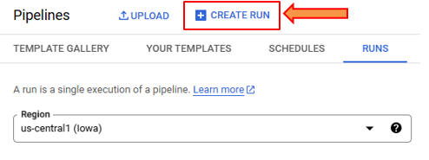
4. Since we are interested in creating a ML model pipeline for BigQuery, the first step is to check templates. If it already exists, our work is significantly reduced.
Specify the region and template.
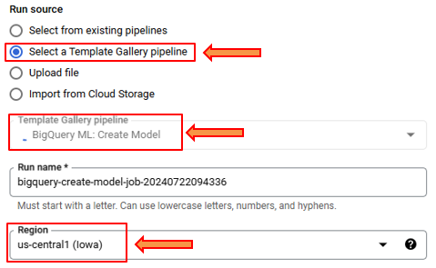
5. Since we want our pipeline to run multiple times, we chose the recurring option and specify the date in unix-format. Our frequency is entered as such that the pipeline will run at 9 AM every Tuesday.
An alternate method can be to run the pipeline whenever ‘n’ number of records are added to BigQuery. However, that requires much more configurations.
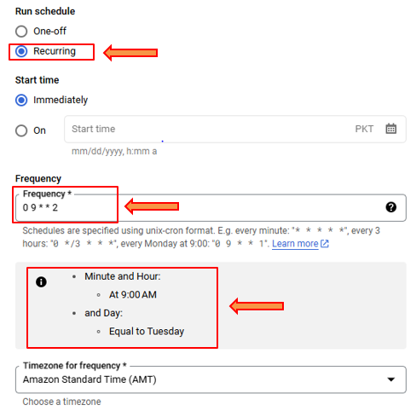
6. We do not want the model to end so we chose, “Never”.
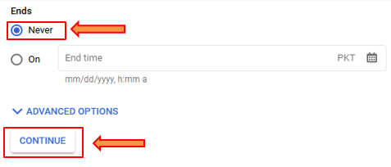
7. In the output directory, we must specify an existing storage bucket. We have chosen one at random for demonstration.
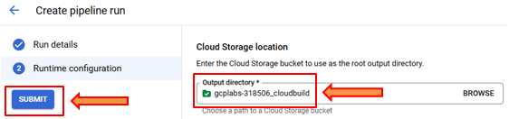
8. The pipeline is created and we can observe its properties.
